**Ocean Wind Fields (OWI) component**

The Sentinel-1 Level 2 OWI component is an ocean surface wind vector (speed and direction) estimated from a Sentinel-1 Level 1 SAR image by inversion of its associated Normalized Radar Cross Section (NRCS).

OWI is a ground range **gridded estimate of the surface wind speed and direction at 10 m above the surface** derived from internally generated Level-1 GRD images of SM, **IW** or EW modes.

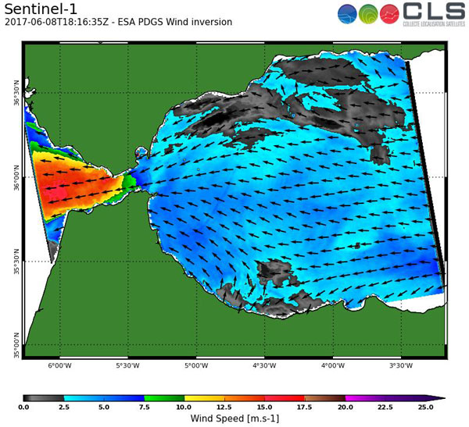

More: <https://sentinel.esa.int/documents/247904/3861173/Sentinel-1-Ocean-Wind-Fields-OWI-ATBD.pdf>

You can read below about the Ocean Wind Fields products that are available for our domain of interest.

**Sentinel 1A & 1B Level 2** **Interferometric Wide-swath Mode (IW) Mode OCN Product**

The Sentinel-1 SAR can be operated in one of the four following nominal acquisition modes:

* Stripmap Mode (SM)
* **Interferometric Wide-swath Mode (IW)**
* Extra-Wide swath Mode (EW)
* Wave Mode (WV)

**The OWI component is a set of wind vectors for each processed L1 input product. The norm is wind speed in (m/s) and the argument is wind direction in (degN) (degrees with respect to the North clockwise). The spatial resolution of the vector is directly related to the area on which the NRCS is computed.** Apart from wind vector, other variables estimated during ocean surface wind inversion such as longitude, latitude, incidence angle, NRCS are included in the L2 product. Some key sensor parameters of L1 product are also annotated to the product. **The spatial coverage of each wind vector of the OWI component is equal to the spatial coverage of the corresponding L1 WV-SLC** or sub-images extracted from the L1 SM or TOPS-GRD product. **It is limited to ocean coverage.** In the case of the SM or TOPS modes, the L1 product is divided into cells. A wind vector is estimated for each cell leading to a grid for each OWI component variable. Sentinel-1 wind processing unit system consists of a calibration unit followed by an inversion unit. Data from SM and TOPS modes are not available for our domain of interest.

**Ocean Swell Spectra (OSW) component**

The Sentinel-1 Level 2 OSW component of the OCN product is the two-dimensional ocean surface wave spectra estimated from a Sentinel-1 Level 1 Single-Look Complex (SLC) SAR image by inversion of the corresponding image cross-spectra. The cross spectra are computed by performing interlooking in azimuth followed by co- and cross-spectra estimation among the detected individual look images. The image from which a single OSW is computed can be a SLC imagette from the WV mode.

**OSW includes an estimate of the wind speed and direction per swell spectrum (single values for every image or vignette).** The OSW is generated from Stripmap and Wave modes only. For Stripmap mode, there are multiple spectra derived from internally generated Level-1 SLC images. **For Wave mode, there is one spectrum per vignette**.

The spatial coverage of one cell of the OSW component is equal to the spatial coverage of the corresponding L1 WV-SLC or sub-images extracted from the L1 SM-SLC product. **It is limited to ocean areas.**

More: <https://sentinel.esa.int/documents/247904/349449/S-1_L2_OSW_Detailed_Algorithm_Definition.pdf>

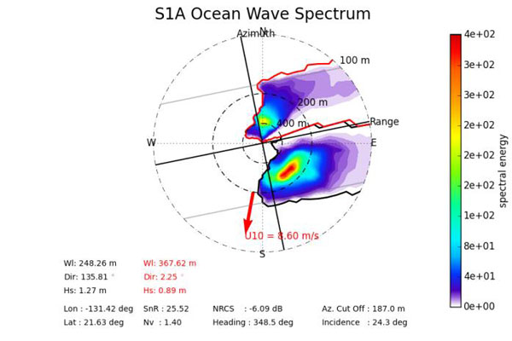

**Sentinel 1B Level 2 Wave Mode (WV) OCN product**

The Processed Ocean (OCN) product contains three sub-products: the **Ocean Swell Spectra** (OSW) component, the **Ocean Wind Field** (OWI) component, and the **Radial Surface Velocity** (RVL) component. These three components are all merged into a common OCN product for the Wave Vignette (WV) and Stripmap (SM) modes. **Wave Vignette (WV) sensor mode data are available for our domain of interest.**

**For WV mode, there is no grid. In this case, the resolution of the components is simply the size of the imagette: 20 km by 20 km at 5 m by 5 m spatial resolution, every 100 km along the orbit, acquired alternately on two different incidence angles. Vignettes on the same incidence angle are separated by 200 km.** Swaths alternate incident angles between near range and far range (approximately 23° and 36° respectively).

The three components are estimated from L1 SLC internal products.

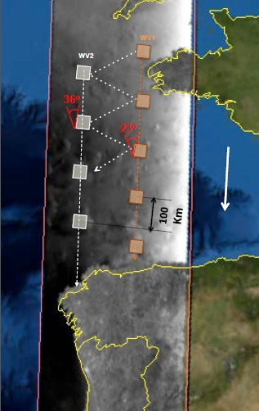

**Data availability**

The OCN products are available at the [Copernicus Open Access Hub](https://scihub.copernicus.eu/dhus/#/home). Data in our domain of interest are available every 12 days.

Here’s an example of the data acquisition process:

1. Right click on the map and draw the polygon for the area of interest. Select the ingestion period, the Mission (Sentinel-1), the Satellite platform (S1A or S1B), the product type (OCN) and the Sensor Mode (WV for the Ocean Swell Spectra or IW for the Ocean Wind Fields products).

**Ocean Swell Spectra**

For the Ocean Swell Spectra, data are available from the Sentinel 1B satellite only, every 12 days. Every product is an along track of 42 vignettes or images. For each track, the closest image to our domain of interest is represented by the Image Number 31 (in the name of each netcdf file) out of the total of 42 images, with coordinates 70.6W and 40.3N. Therefore, only 1 vignette is related to our domain of interest (Number 31).

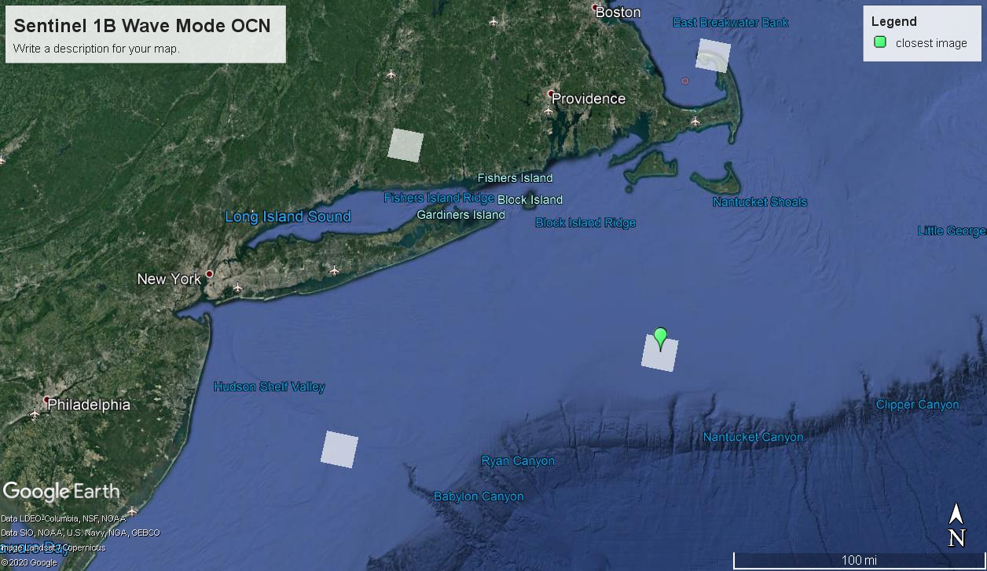

1. On the Copernicus Open Access Hub, we must choose the Ingesting Period, the Mission (Sentinel 1), the Satellite Platform (S1B), the Product Type (OCN) and the Sensor Mode (WV).

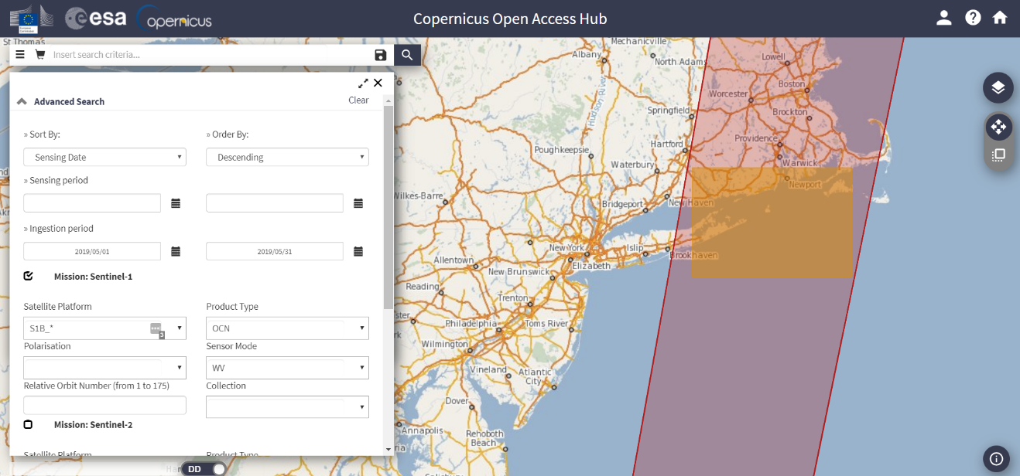

1. Search, select all the available products and add to cart or download each one separately.

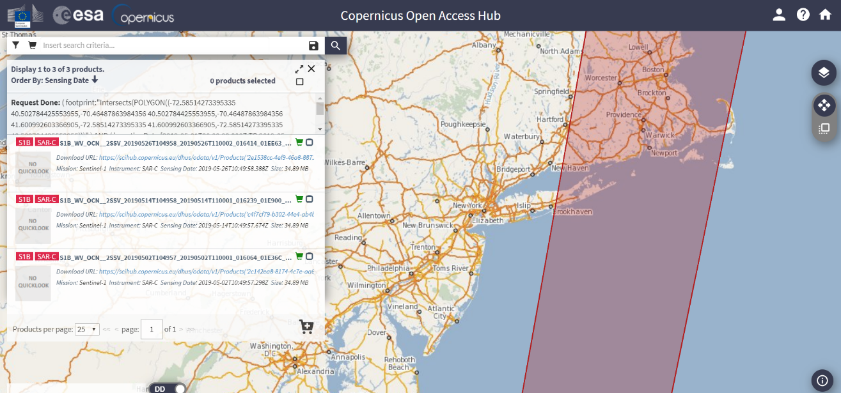

1. Visualization using ESA’s SNAP software of a single product in our domain of interest (Image number 31):

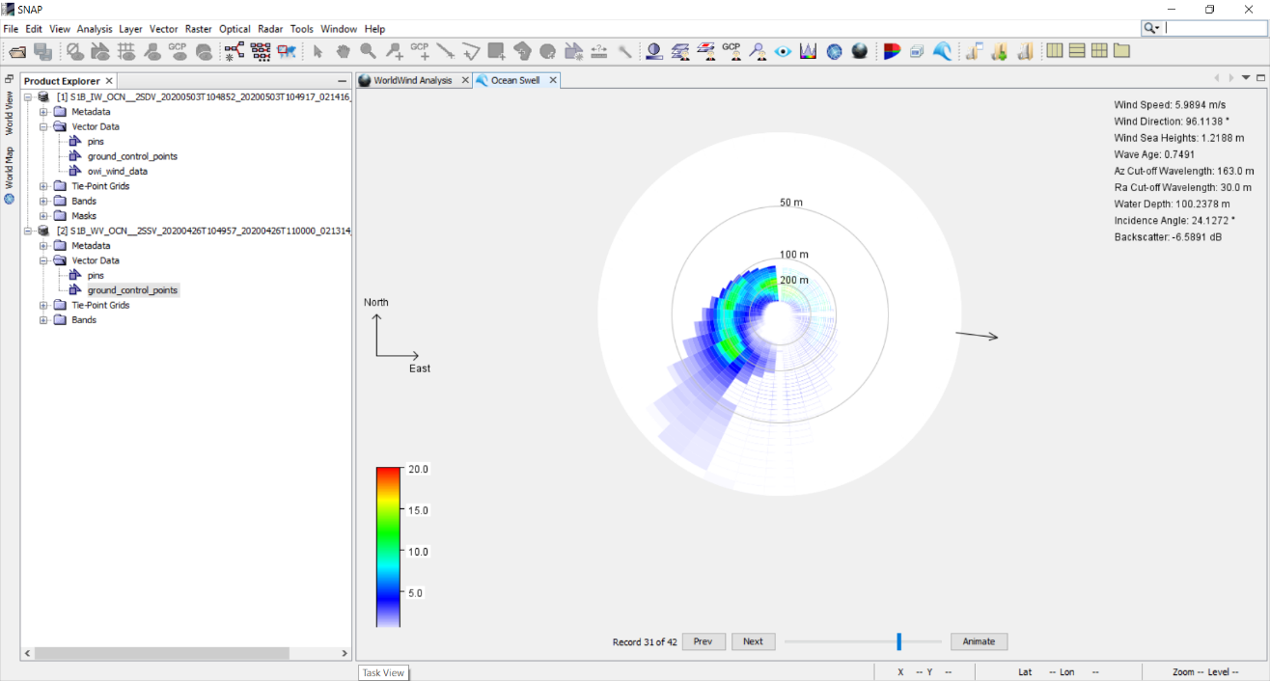

**Ocean Wind Fields**

For the Ocean Wind Fields (OWI), data are available from both the Sentinel 1A and 1B satellites, every 12 days (for images in the same area). The difference between the OWI and the OSW products is that OWI are produced when the satellite is operating in IW sensor mode.

* Sentinel 1A

An example of the Sentinel 1A OWI products in our domain of interest. The temporal difference between the images represented by the boxes at the left and the boxes at the right is 7 days:

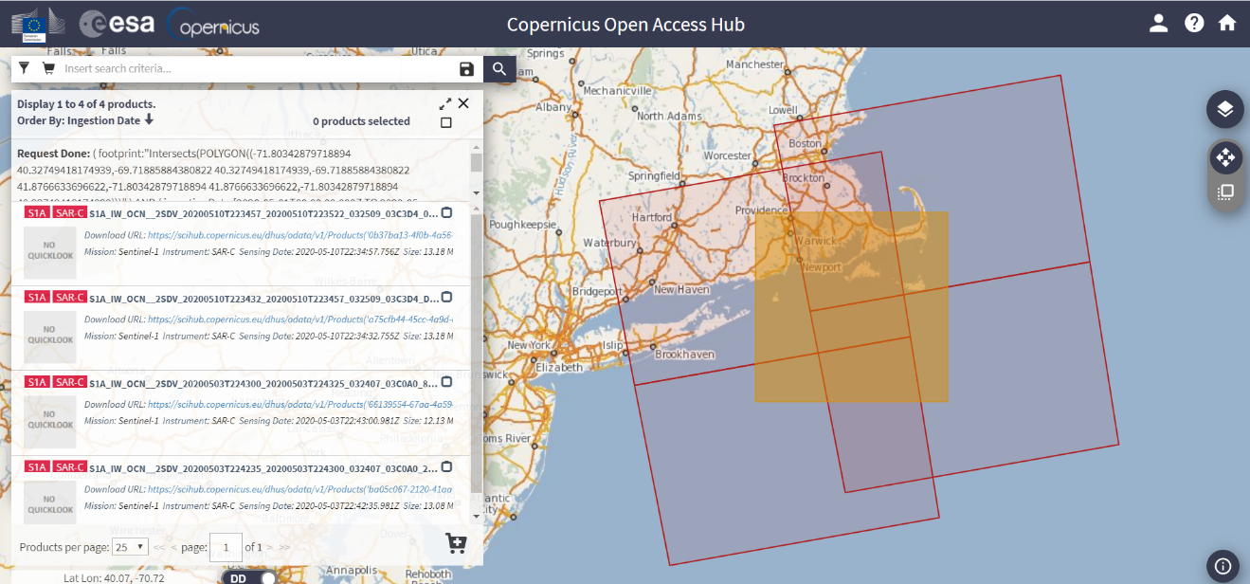

The corresponding visualization of the product in the upper left box using SNAP software:

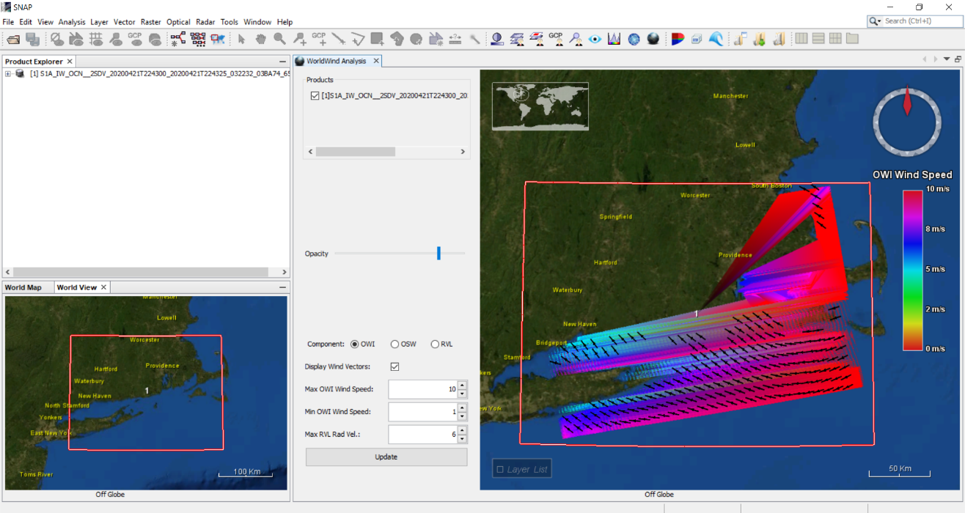

* Sentinel 1B

An example of the Sentinel 1A OWI products in our domain of interest:

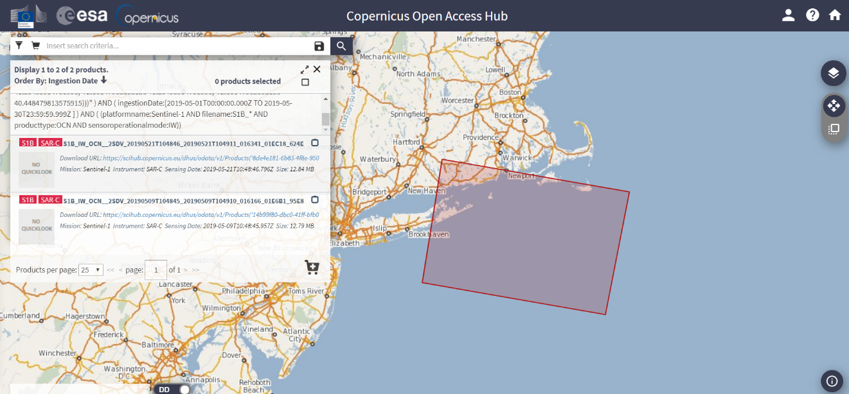

And the corresponding visualization of the product using SNAP:

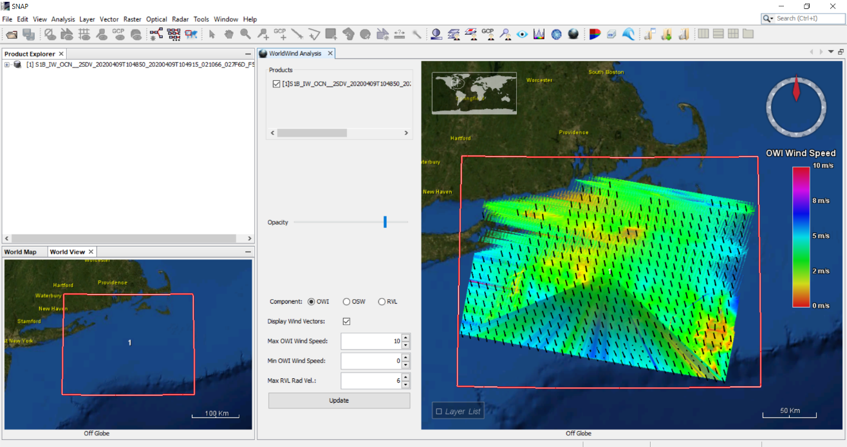

**Dataset Naming Convention**

Sentinel-1 data products are distributed in the Sentinel Standard Archive Format for Europe (SAFE) format (<https://sentinels.copernicus.eu/web/sentinel/user-guides/sentinel-1-sar/data-formats/safe-specification>).

Within a product folder, measurement data sets and annotation data sets follow a naming convention with alphanumeric characters separated by a dash (-). All characters are lower case, but the datatake ID that can be annotated either in lower or upper case.

The Mission Identifier (mmm) denotes the satellite and will be either s1a for the Sentinel-1A instrument or s1b for the Sentinel-1B instrument.

The Swath Identifier (sss) identifies the s1-s6 beams for SM mode, **iw1-iw3 or iw for IW mode**, ew1-ew5 or ew for EW more and **wv1-wv2 for WV mode**.

Product Type (ttt) can be slc, grd or **ocn**.

Polarisation (pp) can be:

* hh (single HH polarisation)
* vv (single VV polarisation)
* hv (single HV polarisation)
* vh (single VH polarisation).

The product start and stop date and times are shown by fourteen digits representing the date and time separated by the character 't'.

The absolute orbit number at product start time (oooooo) will be in the range 000001-999999.

The mission data-take identifier (dddddd) will be in the range 000001-FFFFFF.

The image number (nnn) identifies each individual image. **WV vignettes each have their own image number as do each swath and polarisation image for SM, IW and EW**.

The file extension denotes the data format of the file and could be **nc**, xml, html, kml, xsd or png.

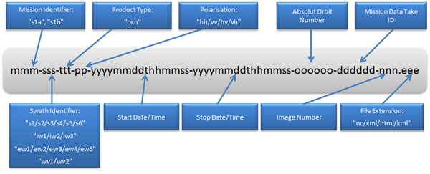

An example of the aforementioned image data file is:

s1b-wv1-ocn-vv-20200426t105716-20200426t105719-021314-028752-031.nc